Shiladitya Bhattacharjee, PhD  High Performance Cloud Computing Center (HPC³)  Universiti Teknologi PETRONAS (UTP),  Bandar Seri Iskandar, 31750 Tronoh, Perak, Malaysia.  Phone:+60-0165454652 (M)  E-mail:shiladityaju@gmail.com | 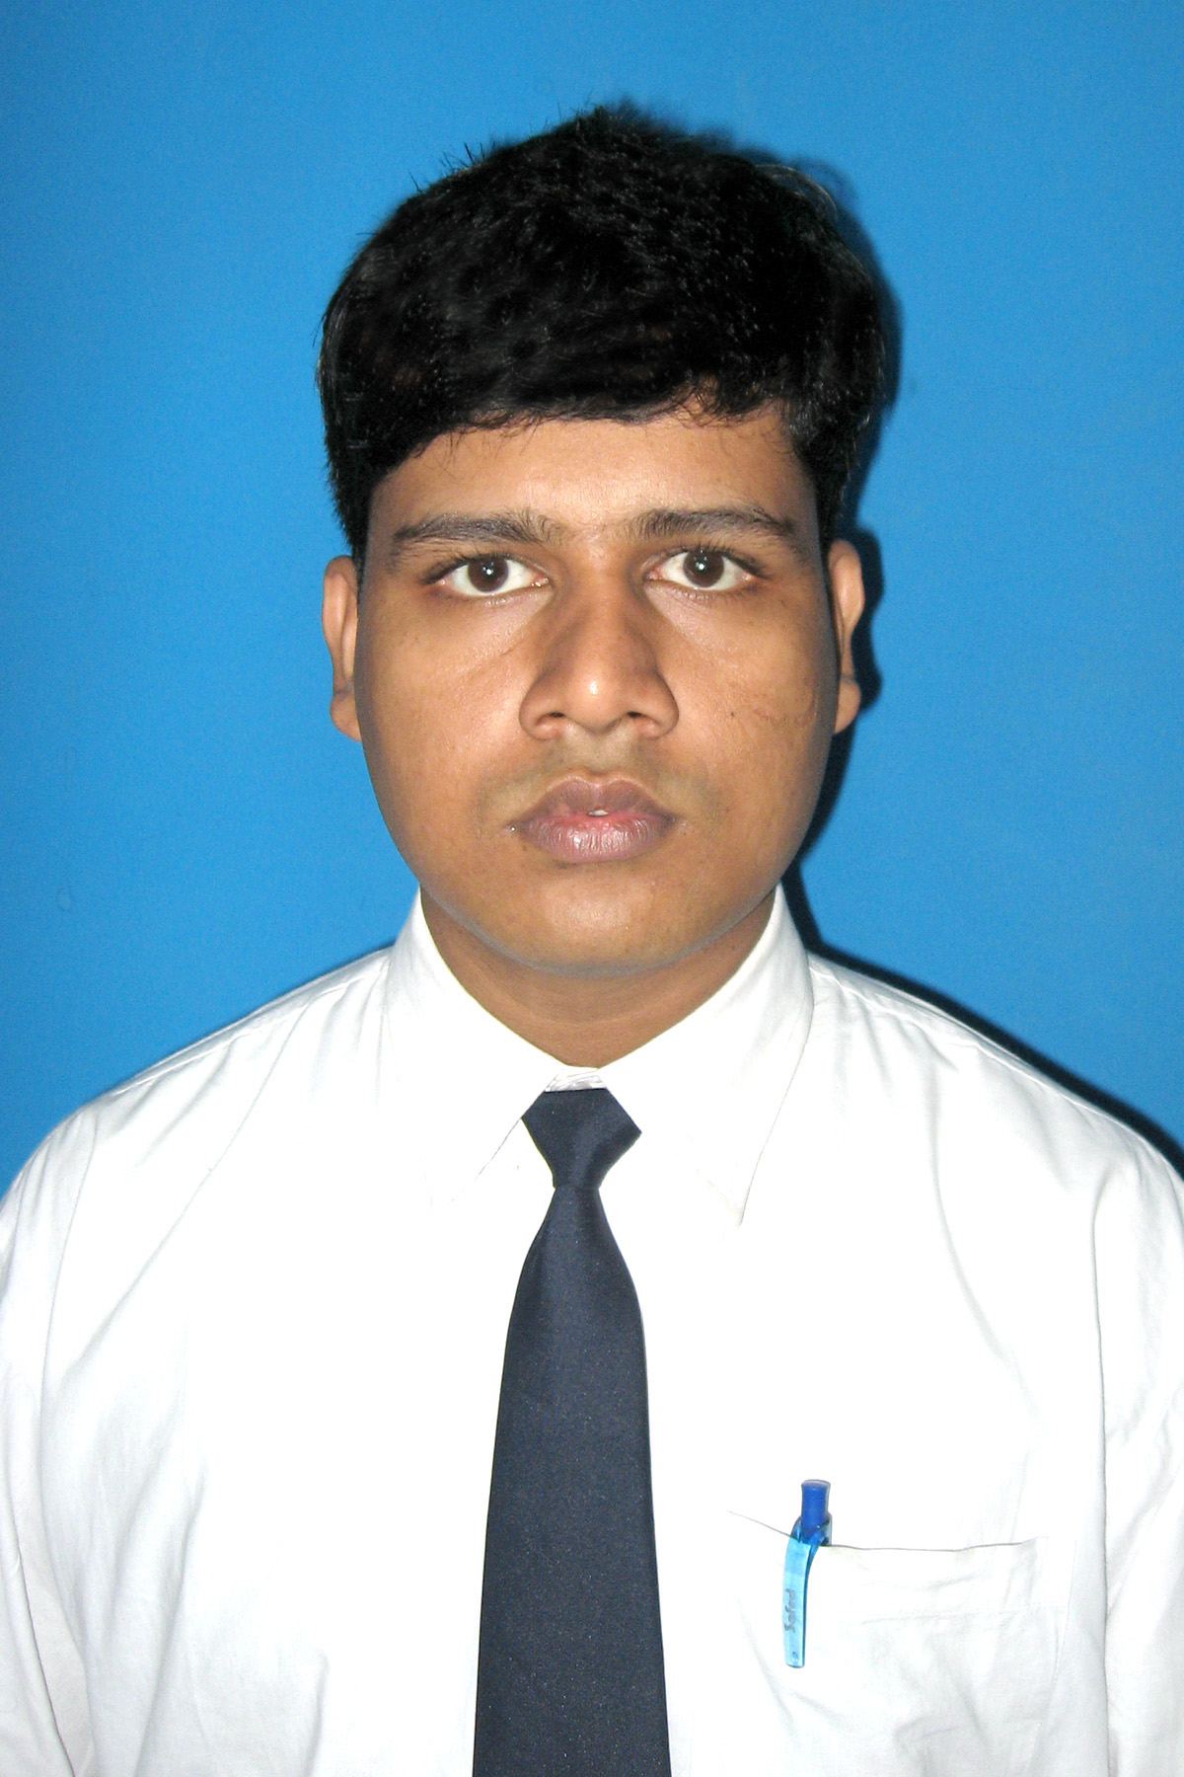
Career Objective

Want to be an excellent Researcher (Academic/Industrial), by utilizing my technical expertise and experimental skills and by contributing to the development and better understanding of science and technology for benefit.

Working Experience

- Completed Hitachi and High Performance Cloud Computing Center of Universiti Teknologi PETRONAS collaborative Project related to Seismic SEGY data processing through Hadoop (October 2016 to March 2017)

- Completed the HPC³ (UTP) project under Dr. Mohamed Nordin B. Zakaria as Graduate Research Assistant (GRA): (1) Handling Big Data with MySQL Database, (2) Compatibility testing among Cassandra, HBase, and MySQL for handling big data, (April 2015 to February 2016).

- Completed the project under Dr. Lukman Bin Abdul Rahim regarding Big Data Processing in visual mode, Labview implementation (IGEN Grant) in 2014 (July to October) at High Performance Cloud Computing Center of Universiti Teknologi PETRONAS

- Guided Internship students (from France and India) at HPC³, UTP from April 2016 to July 2016 (Area Covered: Processing Speed optimization using GPU and Hadoop).

- Worked as an Assistant Professor at Sobhasaria Engineering College (Sikar -Rajasthan, India) from August 2010 to September 2011. (Subject Taught: Data Communication / Network Security and Mobile computing).

- Served as Tutor at UTP from October 2011 to September, 2017. (Subject Taught: Data Structure, Data Communication, Object Oriented Programming, Structure Programming, Discrete Mathematics, Probability Theory, Vector Calculus)

Patent

- Shiladitya Bhattacharjee, Lukman Bin Ab. Rahim, Izzatdin B. A. Aziz and Mohamed Nordin Zakaria; “System, Apparatus, and Method for Hiding Secret Data within Cover Data”; Malaysian Patent (Application No. PI 20177015686).
- Shiladitya Bhattacharjee, Lukman Bin Ab. Rahim, Izzatdin B. A. Aziz and Mohamed Nordin Zakaria; “System, Apparatus, and Method for Detecting and Correcting Data Error”; Malaysian Patent (Application No. PI 2017701587).
- Shiladitya Bhattacharjee, Lukman Bin Ab. Rahim, Izzatdin B. A. Aziz and Mohamed Nordin Zakaria; “System, Apparatus, and Method for Compressing Data”; Malaysian Patent (Application No. PI 2017701588)

Grants and Funds

- Big Data Transfer Over Heterogeneous Network Infrastructure, IDEA GENERATION FUND (I-GEN), 2014.

- Development of embedded and integrated compression, cryptography and data integrity firmware onto a computer network interfacing hardware for secure big data transfer over heterogeneous network infrastructure, PROTOTYPE DEVELOPMENT RESEARCH GRANT SCHEME (PRGS). (At Final Stage)

Copyright

2016:
- Advanced Compression on GPU
- Advanced Error Checking and Correction on GPU
- Advanced Steganography on GPU
- Advanced Pattern Generation on GPU
2015:
- Fixed Length Based Lossless Compression Technique
- Generation of Encrypted String (Using SDES) and Pattern String and Information Retrieval From Them
- Incorporation of Error Control Bit and Error Control Operation Technique
- Creation of Stego File and Retrieval of Information from The Stego File

Journal Publication

- Shiladitya Bhattacharjee, Lukman Bin Ab. Rahim, Izzatdin B.A. Aziz,” A Lossless Compression Technique to Increase Robustness in Big Data Transmission System”, International Journal in Advances in Soft Computing and its application (IJASCA), 2015.
- Shiladitya Bhattacharjee, Lukman Bin Ab. Rahim, Izzatdin B. A. Aziz, “Enhancement of Confidentiality and Integrity during Big Data Transmission using a Hybrid Technique”, ARPN Journal of Engineering and Applied Sciences, 2015
- Shiladitya Bhattacharjee, Lukman Bin Ab. Rahim, Izzatdin B. Aziz, “A Hybrid Technique for Enhancing Data Integrity in Big Data Transmission Environment”, Jurnal of Teknolgi, 2016.
- Shiladitya Bhattacharjee, Ma Jie, “A Protocol for Selecting the Strongest and Authentic Hotspot for Transferring Big Data in Wireless Infrastructure”, Jurnal of Teknologi.
- Ma Jie, Shiladitya Bhattacharjee, “Scalability Performance Evaluation of Open Source Seismic Processing Package based on High Performance Computer Clusters”, Jurnal of Teknologi.
- Lukman Ab. Rahim, Krishna Mohan Kudiri, Shiladitya Bhattacharjee, “Framework for Parallelization on Big Data”, PLOS ONE, 2017(Submitted).

Book Chapters
- Lukman Bin Ab. Rahim, Shiladitya Bhattacharjee, and Izzatdin B. A. Aziz. "An Audio Steganography Technique to Maximize Data Hiding Capacity along with Least Modification of Host." Proceedings of the First International Conference on Advanced Data and Information Engineering (DaEng-2013). Springer Singapore, 2014.
- Shiladitya Bhattacharjee, Lukman Bin Ab. Rahim, Izzatdin B. A. Aziz, “Big Data Compression for Transmission over Network”, High Performance Cloud Computing for big data application.
- Shiladitya Bhattacharjee, Lukman Bin Ab. Rahim, Izzatdin B. A. Aziz, “An Audio Steganography for Securing Big Data Transmission”, High Performance Cloud Computing for big data application.

Conferences

- Shiladitya Bhattacharjee, Lukman Bin Ab. Rahim, and Izzatdin B.A. Aziz. "A secure transmission scheme for textual data with least overhead." 2014, Twentieth National Conference on Communications (NCC), IEEE, 2014.

- Shiladitya Bhattacharjee, Lukman Bin Ab. Rahim, and Izzatdin B. A. Aziz. "A Multibit Burst Error Detection and Correction Mechanism for Application Layer." Computer and Information Sciences (ICCOINS), 2014 International Conference on. IEEE, 2014.

- Shiladitya Bhattacharjee, Lukman Bin Ab. Rahim, and Izzatdin B. A. Aziz. “Hiding of Compressed Bit Stream into Audio File to Enhance the Confidentiality and Portability of a Data Transmission System”. International Symposium on Mathematical Sciences & Computing Research (iSMSC’15). 2015 International Conference on. IEEE, 2015.

- Shiladitya Bhattacharjee, Lukman Bin Ab. Rahim, and Izzatdin B. A. Aziz. ” A Security Scheme to Minimize Information Loss During Big Data Transmission Over the Internet”. Computer and Information Sciences (ICCOINS), 2016 International Conference on. IEEE, 2016.

- Shiladitya Bhattacharjee, Lukman Bin Ab. Rahim, and Izzatdin B. A. Aziz, Turmo Matthieu. “GPU Based Integrated Security System for Minimizing Data Loss in Big Data Transmission”, International Conference on Pattern Recognition and Machine Intelligence, Springer International Publishing in its LNCS series, 2017 (Accepted).

Professional Qualification

- Doctor of Philosophy (PhD) in Information Technology from Universiti Teknologi PETRONAS (UTP) Malaysia.

- Master of Technology in Information Technology from Jadavpur University, Jadavpur, Kolkata, West Bengal, India (June-2008 to June-2010).

- Qualified Gate-2007 in Information Technology with all India rank-530.

- Bachelor of Technology in Information Technology, from West Bengal University of Technology (State Technical University) Kolkata, West Bangal, India (July 2005 –July 2008).

- Diploma in Information Technology from West Bengal State Council of Engineering and Technical Education, West Bangal India.( July 2002- July 2005)

Summary of Professional Studies

PhD (Information Technology)

Supervisors | Domain | Thesis Title
- Dr. Lukman Bin Ab. Rahim  - Dr. Izzatdin B.A. Aziz | Big Data  Security | A Hybrid Technique in Achieving Confidentiality, Integrity and Robustness for Big Data Transmission

Master of Technology (Information Technology) (June-2008 to June-2010)

Year | 1st semester | 2nd semester | YGPA
2008-2009 (1st yr) | 6.71 | 7.43 | 7.07
2009-2010 (2nd yr) | 9.00 |  | 9.00
Overall YGPA | 7.5
Dissertation Title: | Visual Information Processing (Face recognition)

Bachelor of Technology (Information Technology) (July 2005 –June 2008)

Year | 1st semester SGPA | 2nd semester SGPA | YGPA out of 10
2005-2006 (2nd yr) | 6.20 | 7.37 | 6.78
2006-2007 (3rd yr) | 7.31 | 8.04 | 7.68
2007-2008 (4th yr) | 8.31 | 7.85 | 8.08
Overall DGPA | 7.6

Diploma (Information Technology) (July 2002 –June 2005)

Year | 1st semester | 2nd semester
2002-2003(part I) | 78.3% | 76.9%
2003-2004(part II) | 78.3% | 77.3%
2004-2005(part III) | 75.9% | 79.5%
Overall Percentage | 77.7%

References

- Dr. Lukman Bin Ab. Rahim | Computer and Information Science Department,  Universiti Teknologi PETRONAS (UTP),  Bandar Seri Iskandar, 31750 Tronoh,  Perak, Malaysia  Phone: +605 - 368 7479  Email: lukmanrahim@petronas.com.my
- Dr. Izzatdin B.A. Aziz  - Dr. Mohamed Nordin B. Zakaria | Computer and Information Science Department,  Universiti Teknologi PETRONAS (UTP),  Bandar Seri Iskandar, 31750 Tronoh,  Perak, Malaysia  Phone: +605- 368 7495  Email: izzatdin@petronas.com.my  Head of High Performance Computing Center,  Computer and Information Science Department,  Universiti Teknologi PETRONAS (UTP),  Bandar Seri Iskandar, 31750 Tronoh,  Perak, Malaysia  Phone: +605 -368 8209  Email: nordinzakaria@petronas.com.my

Skill Set

- Time optimization using GPU and Hadoop
- GPU Programming using CUDA
- Big File Handling using Hadoop
- NoSQL Database Handling using HBase and Cassandra
- Visual coding for Big File Handling using LabView
- Competent with C Language, CPP, Java, Matlab, Xilinx.
- Web programming using HTML, CSS, JavaScript, XML, WML, Joomla
- SQL Database Handling wing Oracle all versions, MYSQL and MS Access
- Operating System(Unix, Windows)
- Server Programming using advanced java (JSP, JDBC) and PHP.
- Competent with Network and Socket Programming
- Competent with Shell Programming
- Competent with Trouble Shooting (Computer Hardware) and Networking

Other Training and Achievements

- Qualified in the Graduate Aptitude Test in Engineering (GATE) in 2007 (All India Rank: 530, Score:-354).
- Received Scholarship from Universiti Teknologi PETRONAS (Perak, Malaysia) during PHD as Graduate Assistance (GA).
- One month training experience on Advance Java from DPS Technologies India Pvt. Ltd. NewAlipore, Kolkata, India
- Six months Computer Hardware Diploma from CMC, Konnagar (WB), India
- Six months Campus Connect Training under Infosys & Techno India joint –venture (Saltlake campus, Kolkata (India)) in C, C++, Operating System (Unix),Networking, Database Management System , and Software Engineering, Shell programming (Unix) Server Programming using advanced java (JSP, JDBC) and PHP.
- Trained in Patent writing at Myipo from 28-30 September, 2015

Personal Details
Date : 5th March, 1983
Father’s Name : Bablu Bhattacharjee
Nationality : Indian
Marital status : Married
Sex : Male
Permanent Address : Vill. +Post-Barjora, Dist.-Bankura,
Pin-722202 (West Bengal, India)
Languages Known : English, Hindi and Bengali

*I hereby certify that all the information provided above is true to the best of my knowledge.

Date: 10/10/2016 ---------------------------------
Shiladitya Bhattacharjee

